**SMART STAR EXAMINATIONS BOARD**

**END OF TERM ONE EXAMINATION - 2024**

**HEALTH HABITS**

**BABY CLASS**

My name is…………………………………………..

1. **Trace the eye.**

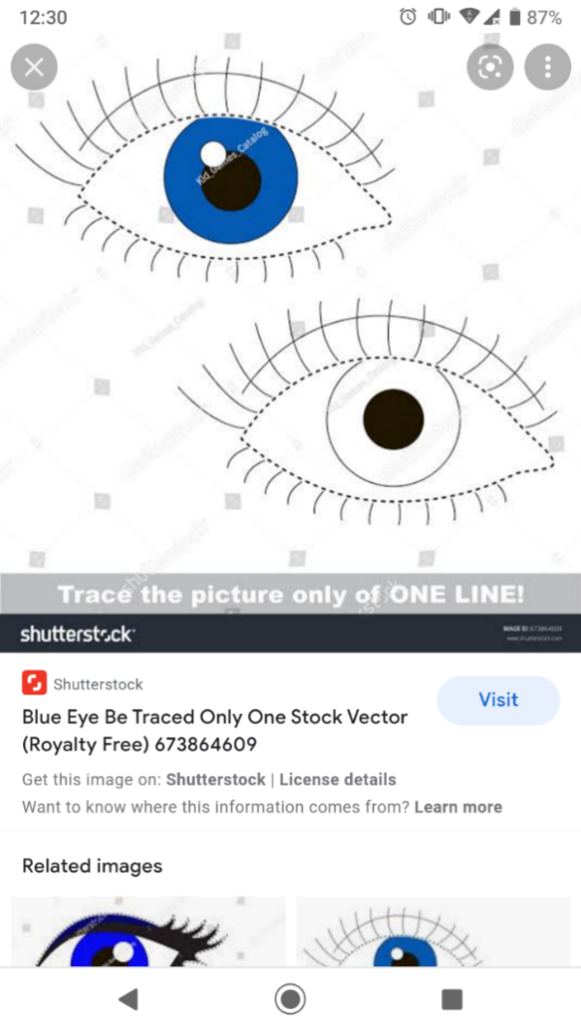

1. **Trace me.**
2. **Tell and shade.**

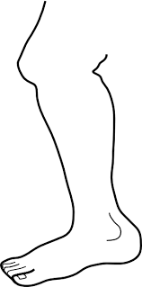

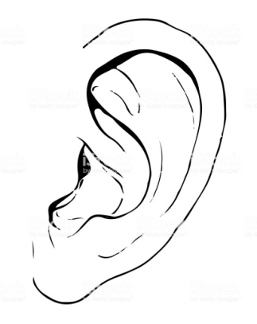

1. 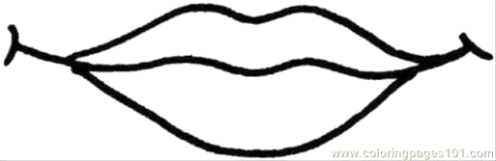**Read and match.**

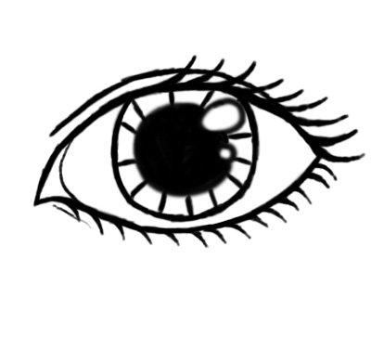

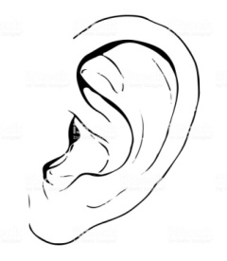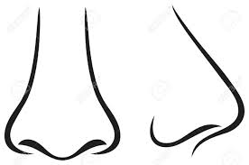



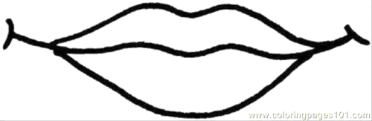





1. **Show me your**

* **Eyes**
* **Nose**
* **mouth**

**END.**